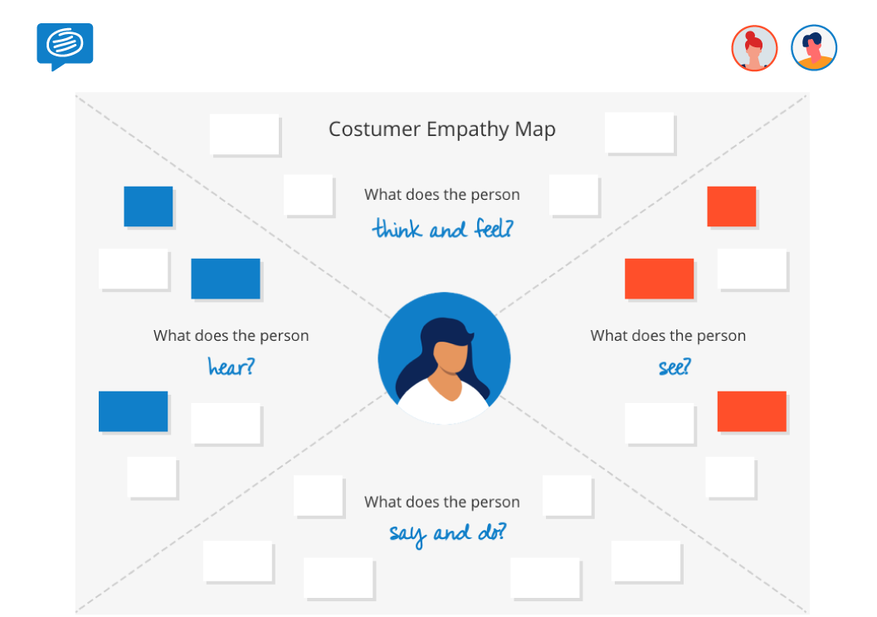

Does it consumes much internet

Is it safe to install?

How to track all of my expenses?

Does it record of money in and out flow?

What does this app do?

Free to use?

U

App doesn’t work

Heard someone got a data loss

How to

manage

budgets?

Can I able to save money?